How to make a tournament bracket in Google Sheets

The tournament bracket consists of a series of rounds or stages, where participants compete against each other in head-to-head matches. The bracket is organized in a hierarchical manner, with each round eliminating half of the remaining participants until only one winner remains.

Today's tutorial will guide you through the process of creating a tournament bracket for four teams. The bracket will resemble the image provided, and you'll learn step-by-step how to construct it. By the end of the tutorial, you'll have a clear understanding of how to design a visually appealing and functional team tournaments.

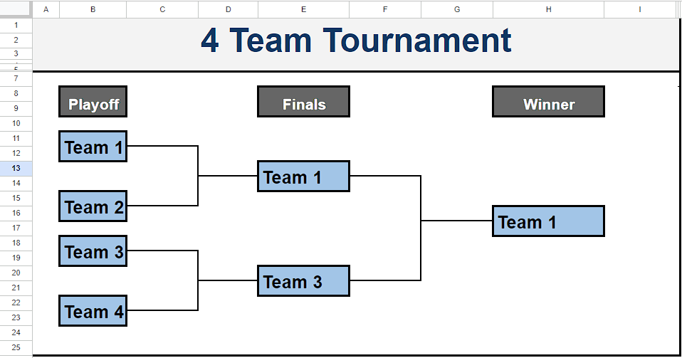

## Step 1 – Make a Team Boxes

* Select the cell under “Playoff” column and merge it with the cell below it.
* Then fill an appropriate light color to make the box distinct.
* Select the merged cell and click on format painter.
* Afterward, replicate the cell formatting onto the subsequent cell while leaving a gap of two rows.
* Then, replicate the cell formatting onto the following cell, ensuring to leave a one-row gap.
* Once more, copy the cell formatting onto the next cell, maintaining a two-row gap between them.
* Then write the Team names in the cells.
* Follow this procedure to make all boxes.



## Step 2 – Draw Team Progress lines

* Use the top, bottom and right borders for drawing team progress lines.
* Follow the same procedure in the following video to draw all Progress lines.



## Step 3 – Remove Gridlines of sheet

* For removing the Gridlines of the cells in the sheet, navigate to the “View Tab”.
* Then, hover your mouse over “Show” option.
* Now, uncheck the “Gridlines” option.



## Conclusion:

This tutorial offers a step-by-step guide to creating a tournament bracket for four teams using Google Sheets. It covers creating team boxes, formatting, drawing progress lines, and removing gridlines. You can download and customize the [template](https://docs.google.com/spreadsheets/d/1eu0TMvK1MEzENQcDmbyNnqQ3a5mfSawmXwQmQxUNB-M/copy) for visually appealing and functional tournament brackets.